Case Study Submission

- Name : Prabhat

- Employee Id : 1121485

- Email Id : prabhat.6@tcs.com

- Your Git Repository URL : https://github.com/prabhat2020/batch10

- Attach the screenshot of your Dockerfile.

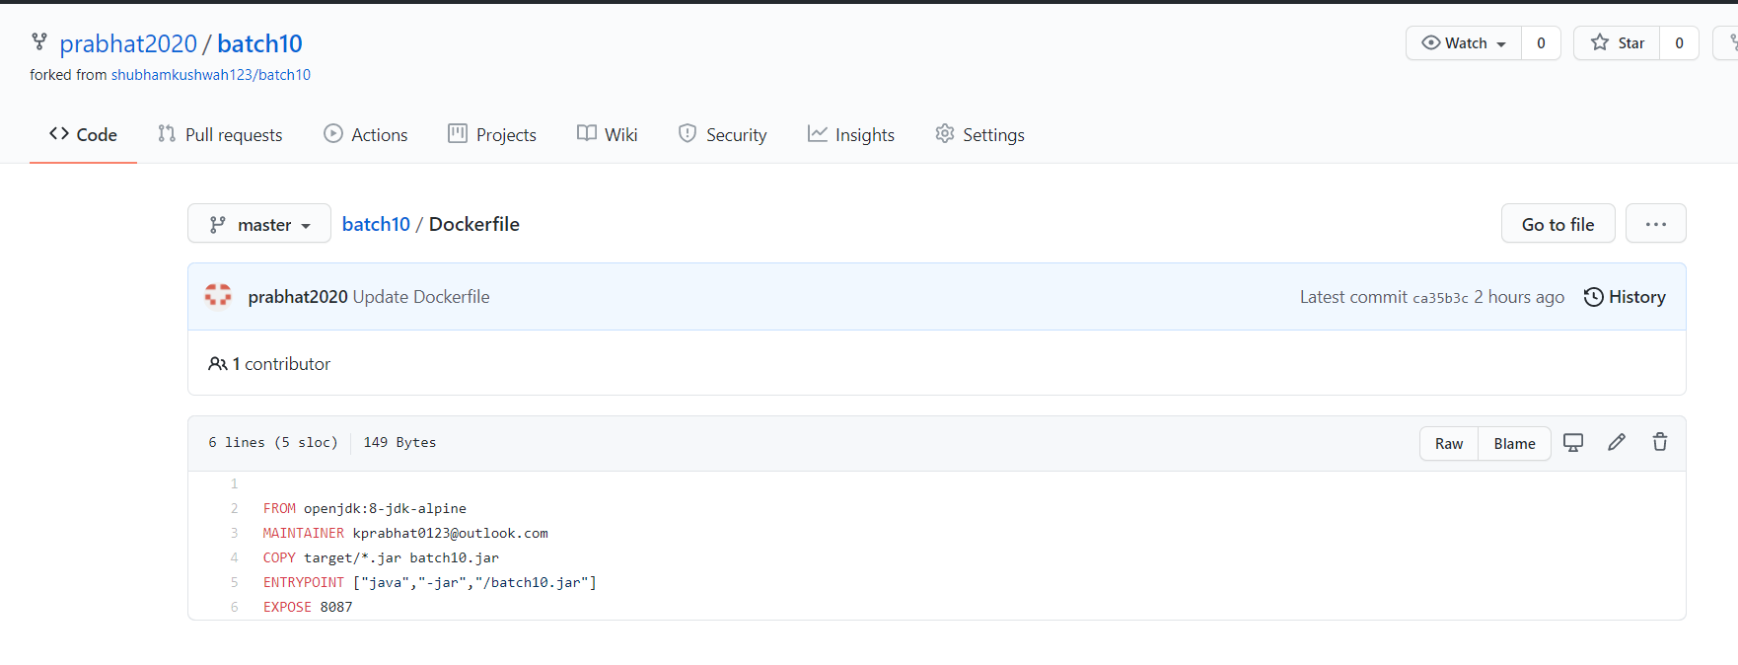

- Attach the screenshot of your Jenkinsfile.
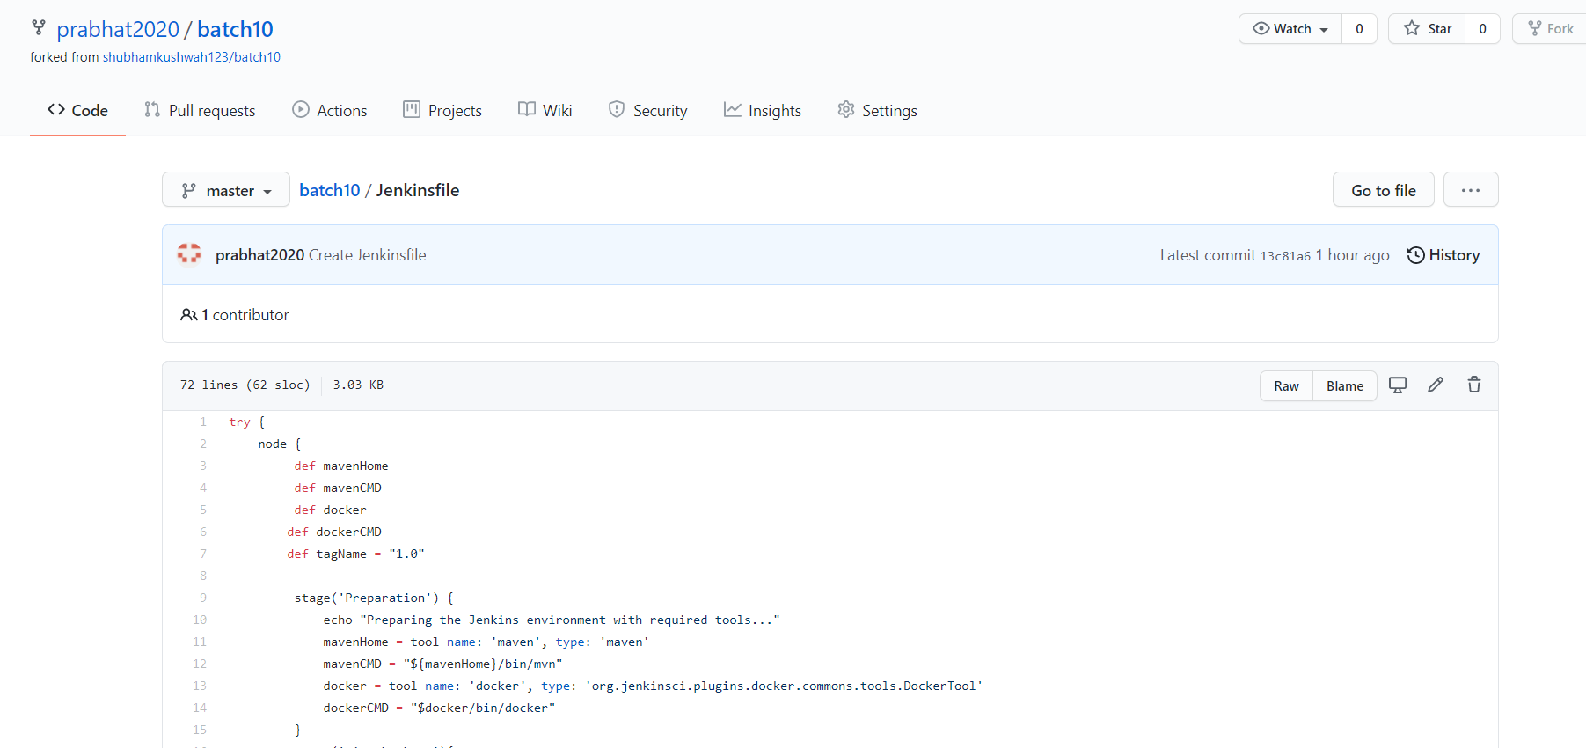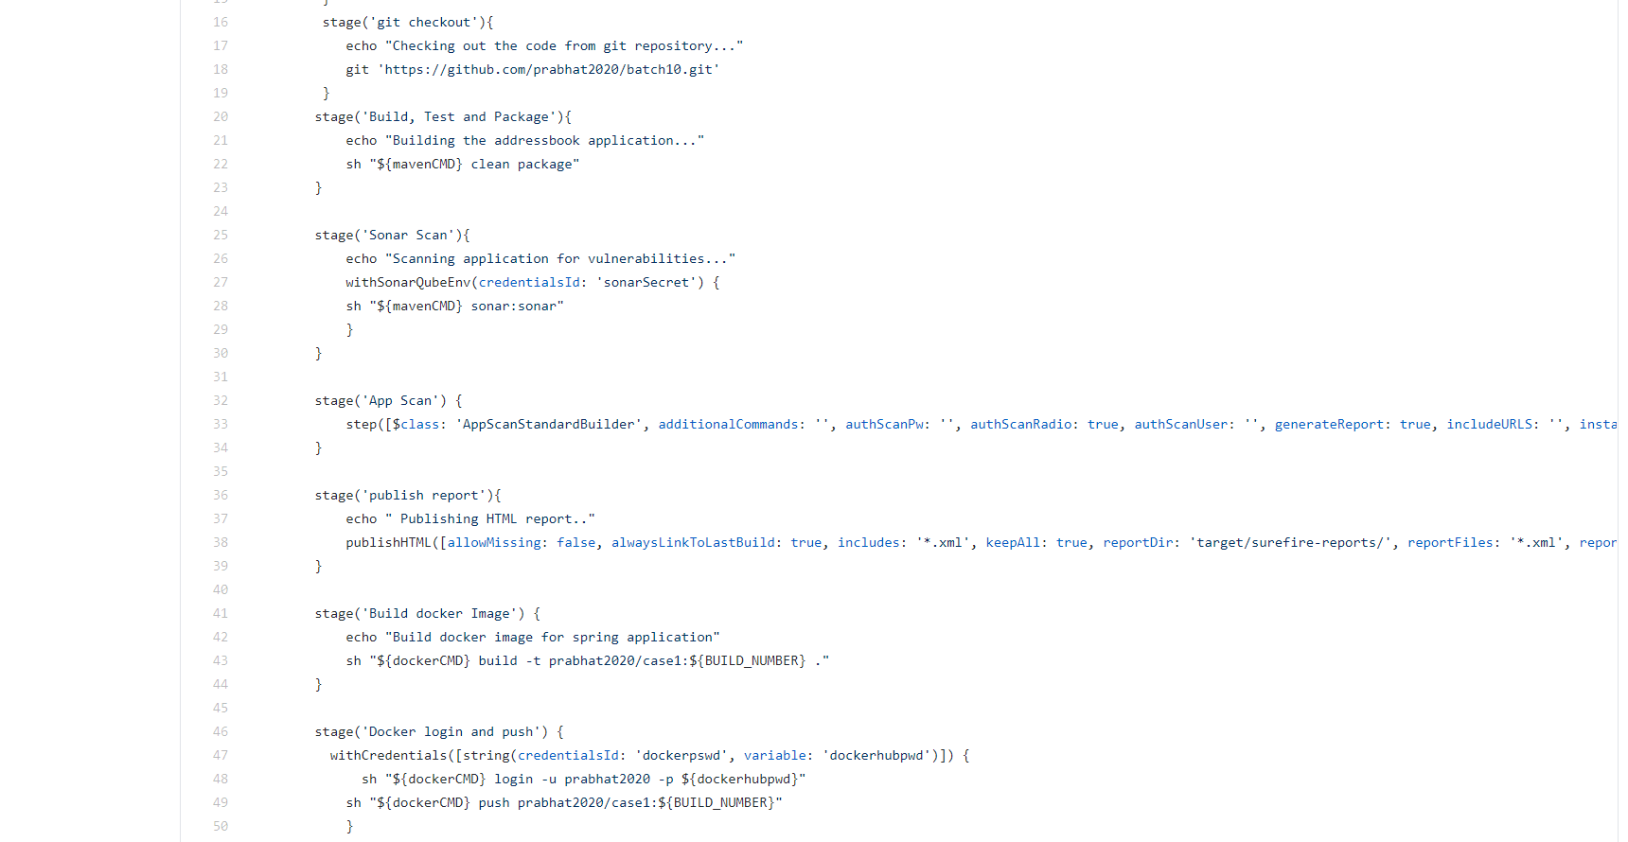
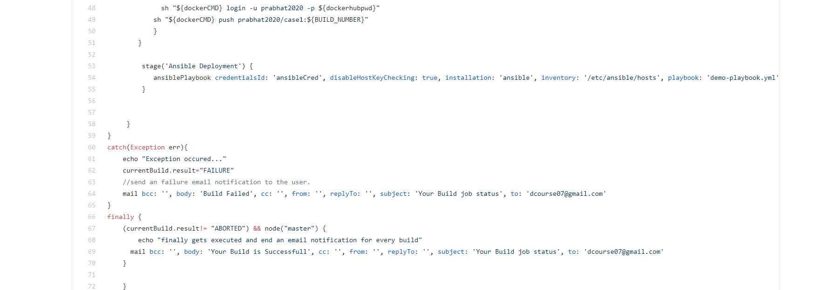

- Upload your Jenkins Log file in the Repo.(Complete log file should display your name on top).
Added
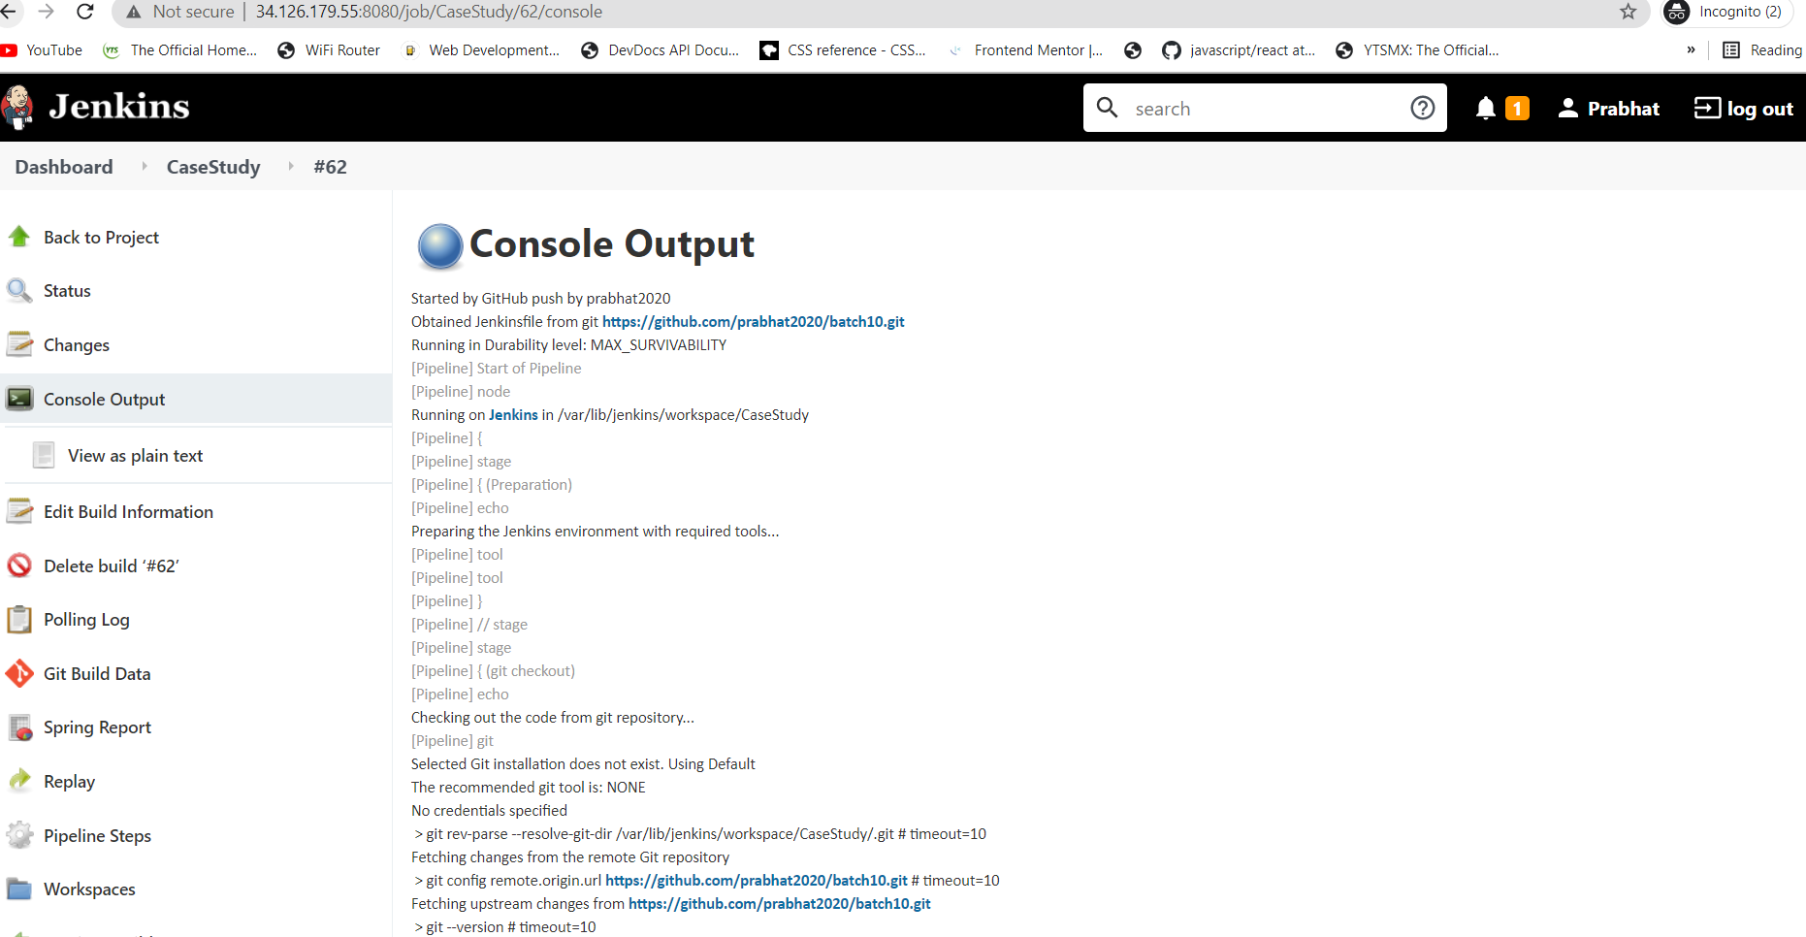

- Attach the screenshot of Jenkins pipeline job status. (All boxes should be green)
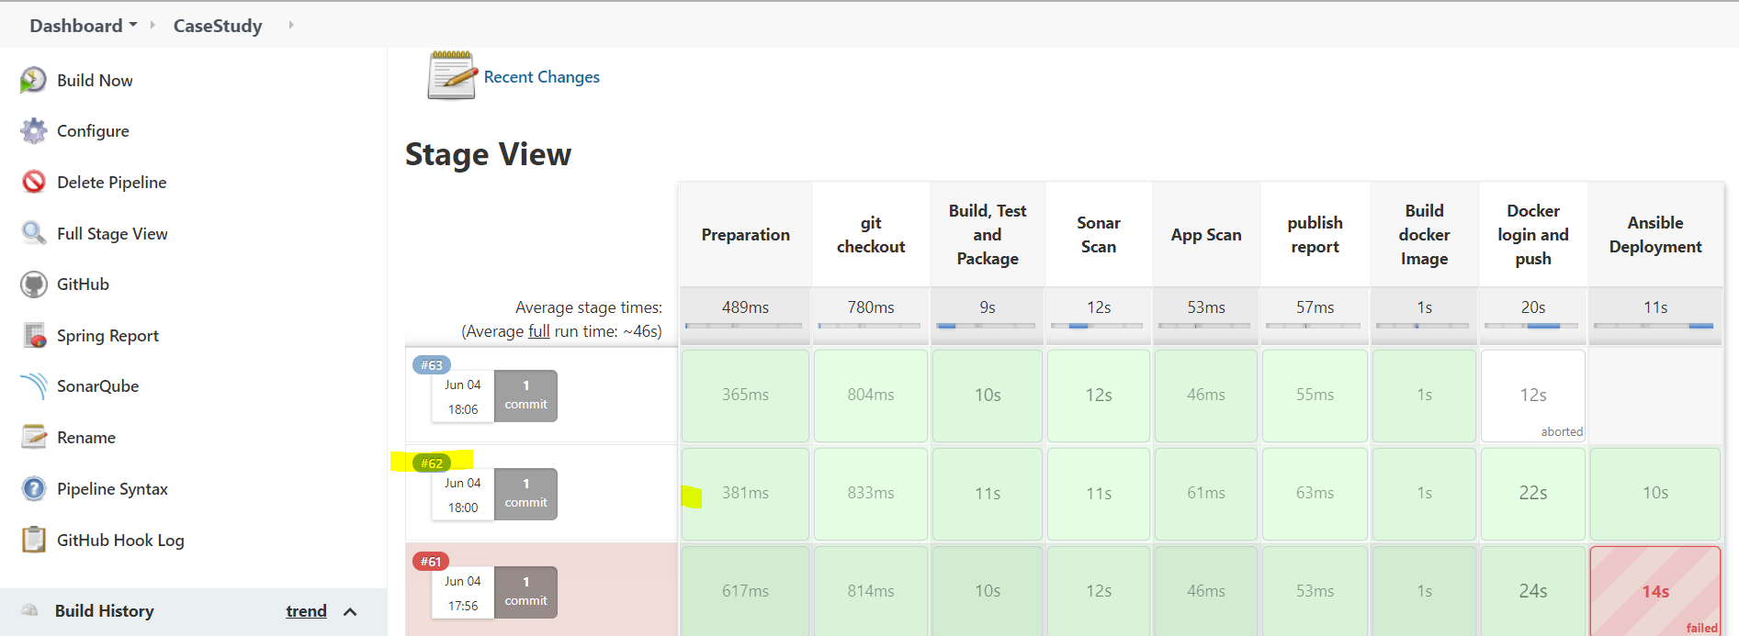

- Attach screenshots of email notification for the Jenkins build.
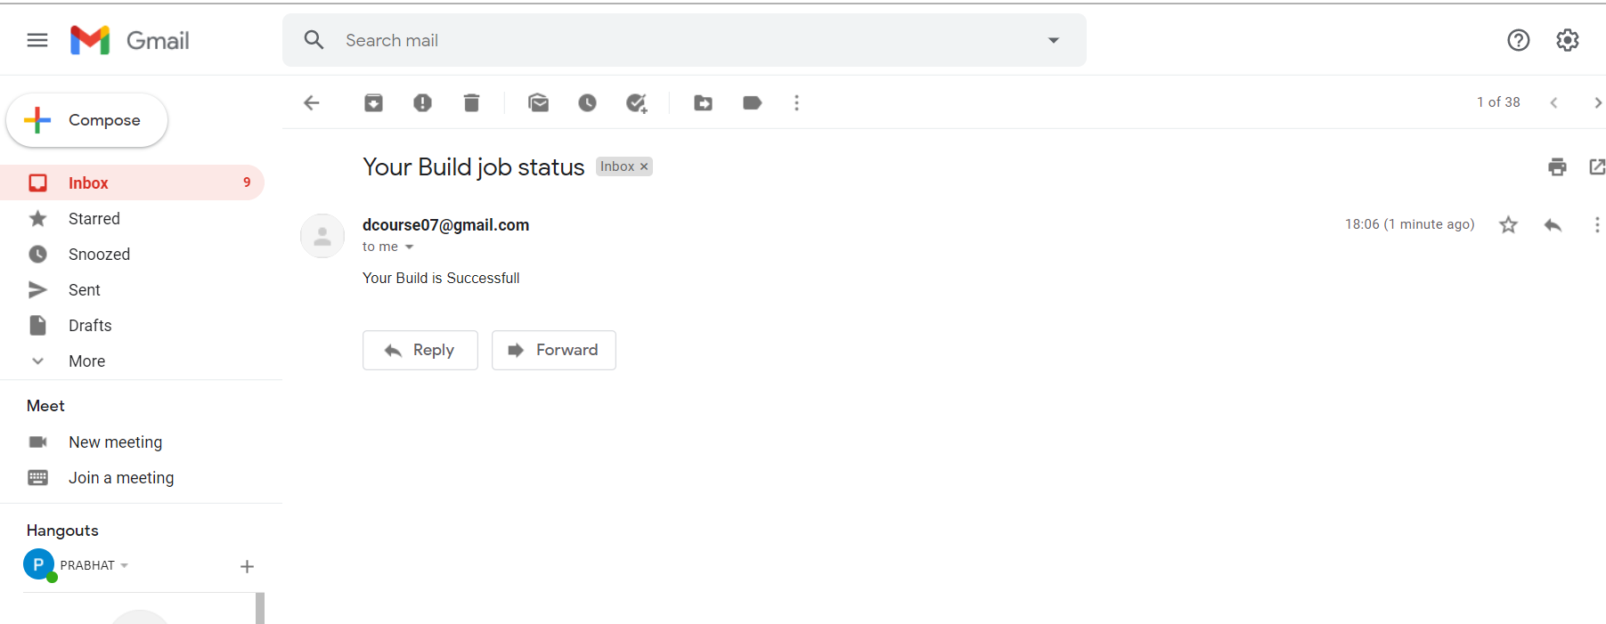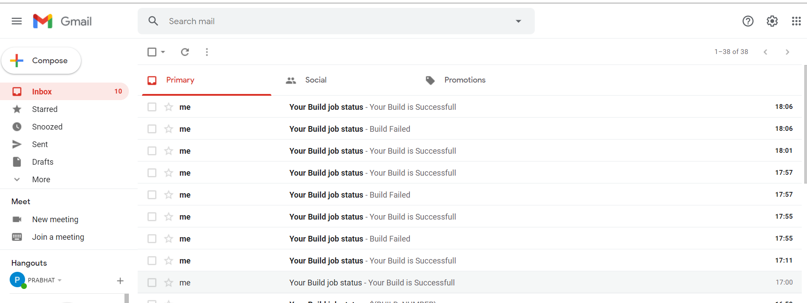

- Attach screenshot of the SonarQube Report.
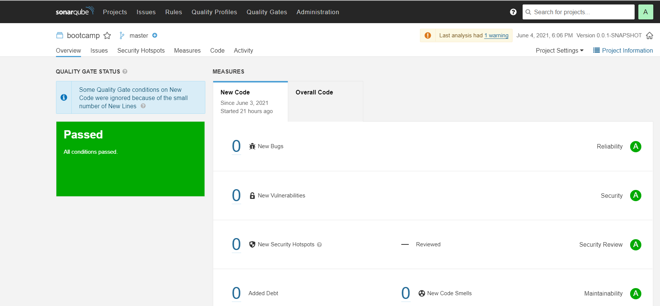

- Attach screenshot of the AppScan Report.
Not able to configure properly.But tried with IBM scanner,need more time to fix it.
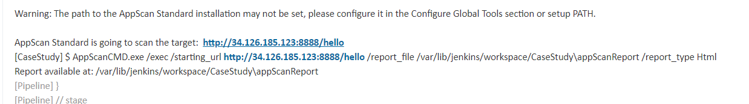

- Attach screenshot of your Ansible Playbook execution logs.
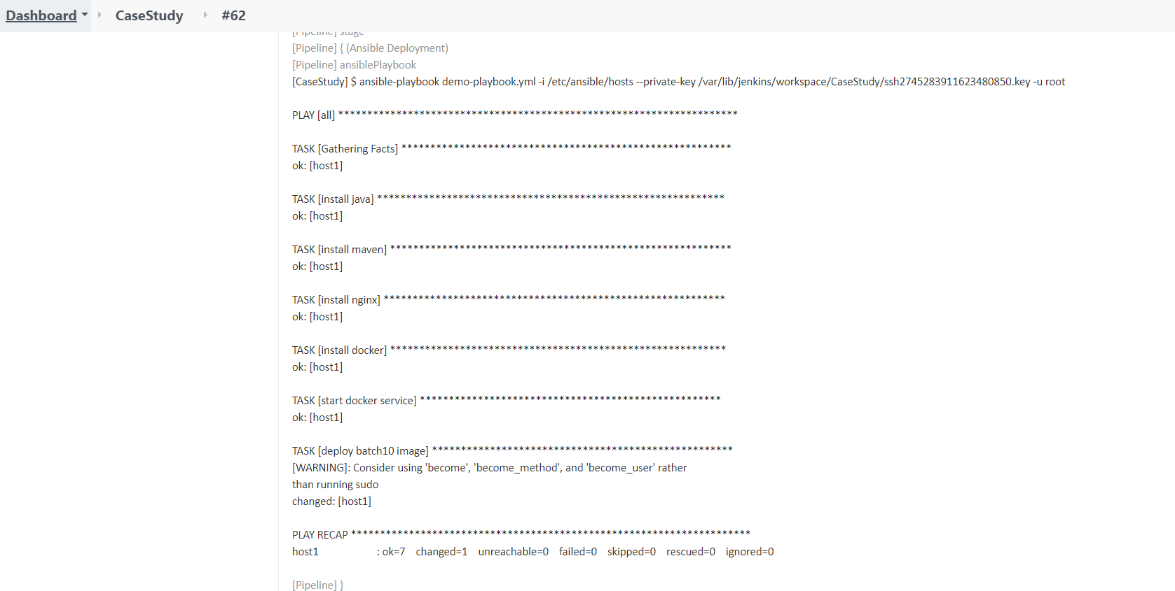

- Attach screenshot of the working application home page on AWS/GCP/Azure.
